
Gas Pressure Sensor (GPSN-100)

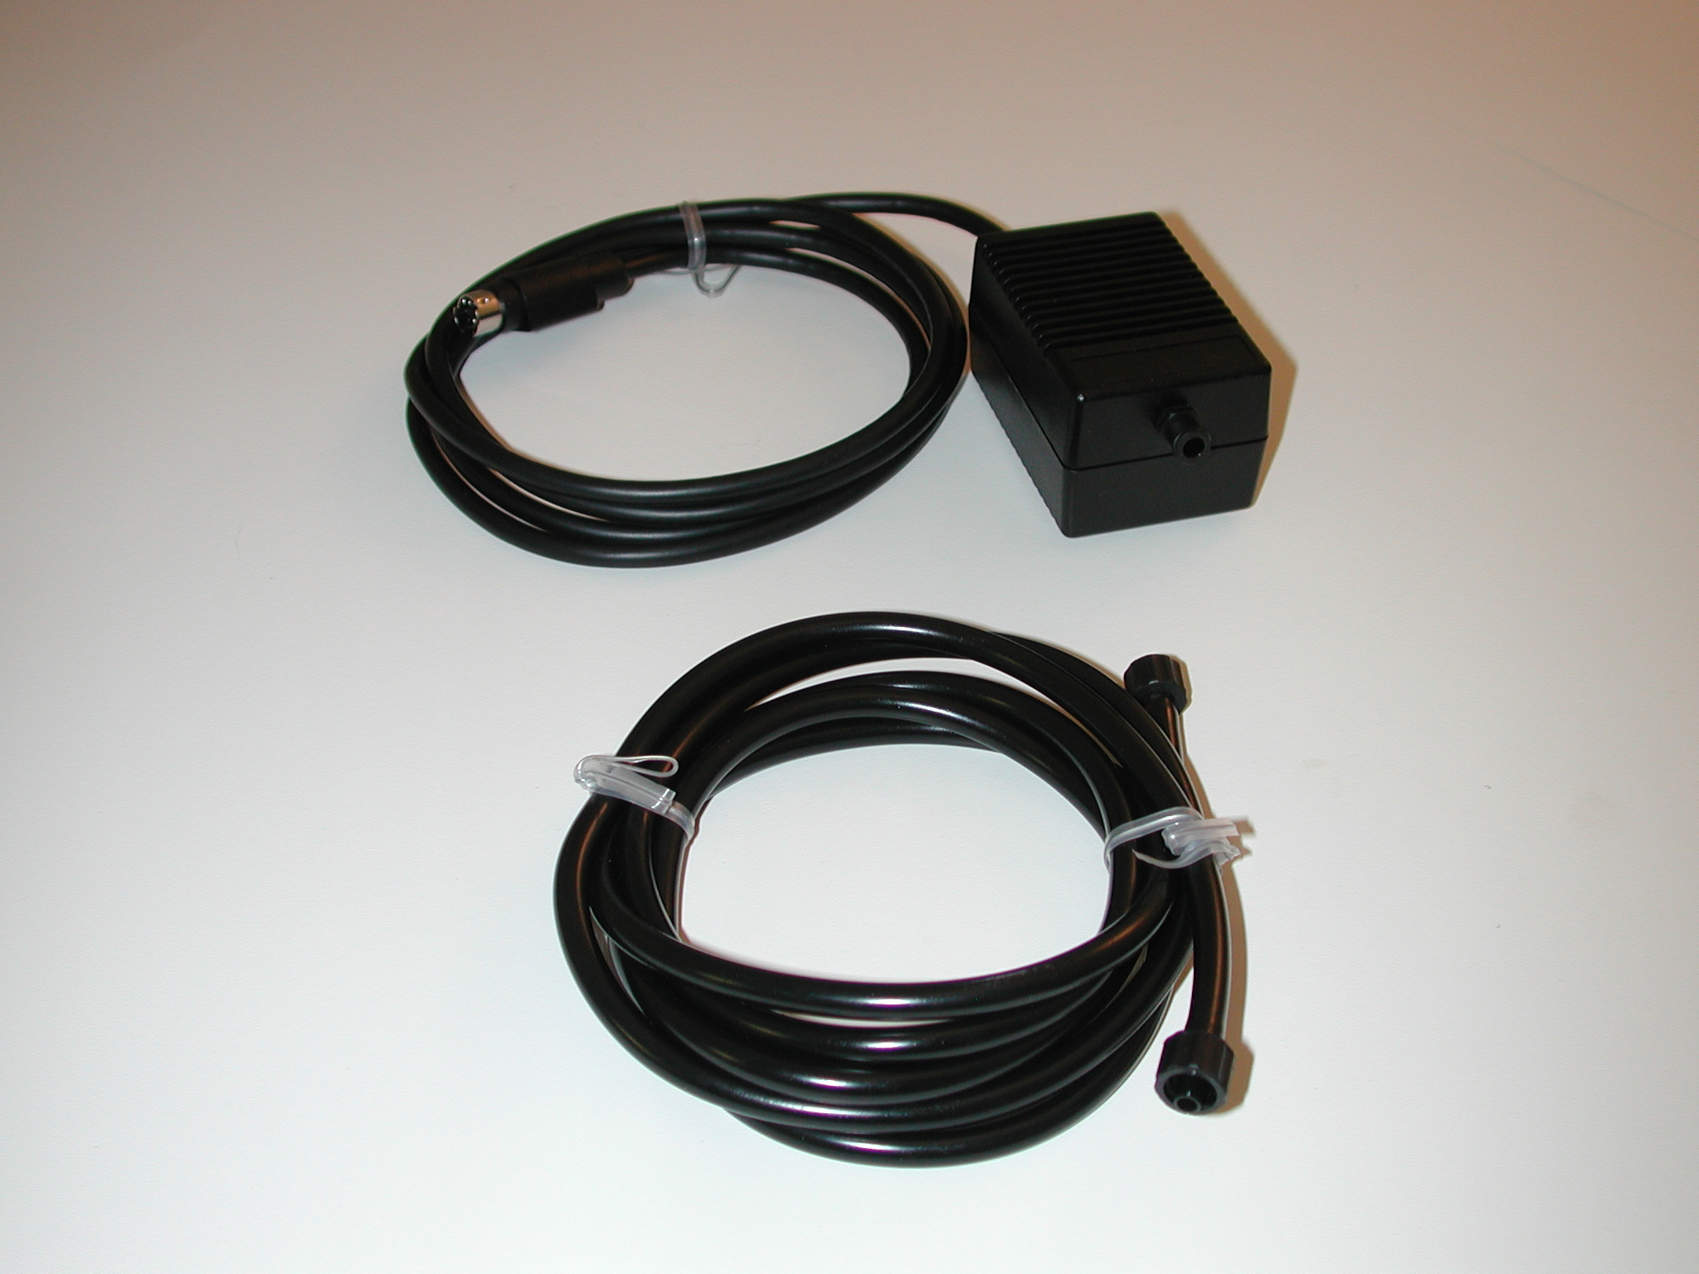
Overview
The iWorx Gas Pressure Sensor (GPSN-100) can be used to measure the pressure of gasses within a range of 20 to 250 kPa. It can be used with the iWorx Blood Pressure Cuff (BP-220) for blood pressure experiments and with the iWorx Pressure Bulb (FT-220) for grip strength experiments.

Figure 1. GPSN-100 and connector tube

Specifications
Input Range | 20 – 250 kPa
Output Range | 0.2 to 4.8V
Calibration | Required every use
Default scaling Value | Vout for 760mm Hg is 1.86V Vout for 860mm Hg is 2.13V
Pressure range | 20 - 250kPa
Connector | MINIDIN 7

Calibration Instructions
1. Plug the IX-ELVIS board into the National Instrument ELVIS platform. Connect the power supply to the ELVIS platform and connect to the computer via a USB cable. Ensure both of the switches are in the on position.
2. Connect the MINIDIN7 connector of the GPSN-100 to the IX-ELVIS board.
3. Connect the BP-200 using the A-BT-220 tubing to the GPSN-100.
4. Open the recording software, select the channel that the GPSN-100 is plugged into and ensure the range is +/-5V.
5. Ensure the manometer on the blood pressure cuff is at 0mmHg. Press record. Stop after a few seconds.
6. Using the manometer apply 200mmHg ensure it is steady and record for a few seconds.
7. Perform a 2pt calibration using the lower voltage as 0mmHg and the higher as 200mmHg.

*Note: If using the IX-MYDAQ the signal may be inverted.

Measurement Instructions
For use with the BP-220
For General Readings:
1. Follow the calibration procedure outlined above.

For use with the FT-220
1. Follow the calibration procedure outlined above.

*Note: If using the IX-MYDAQ the signal may be inverted.

Intended Usage
Iworx Systems Inc. instruments, components, and accessories are designed for educational and research oriented life science applications and investigations. Iworx Systems Inc. does not condone the use of its instruments for clinical medical applications. Instruments, components, and accessories provided by Iworx Systems Inc. are not intended for the diagnosis, cure, mitigation, treatment, or prevention of disease.

Company Information:

Headquarters
iWorx Systems, Inc.
62 Littleworth Road
Dover, NH 03820

Phone: (800) 234-1757
Fax: (603) 742-2455
Website: www.iWorx.com

